Zebra ZD printer (420, 421, 620, 621)
Install this software on the computer that has the printer connected via USB: https://angelpaw.s3.us-west-1.amazonaws.com/zbp.exe
When installing this software make sure to "allow" the app to use the network (you will get a popup from windows to allow and make sure to allow both private and public networks to make sure it works):
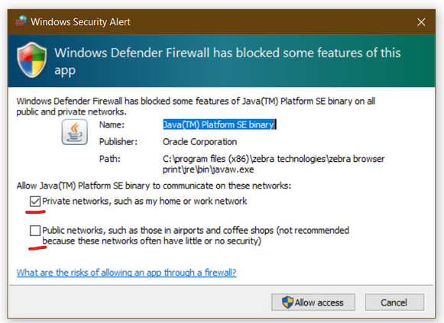
You will also get an agreement screen, sometimes that screen is “minimized” and the “accept” button is not easily visible, you might need to adjust the window size and you should see an “accept” button on the bottom of that screen.
You will also be asked to allow a local domain to the allowed list, it will open a browser page, which will be blocked by the browser, you will still be able to visit that page, depending on the browser, it will say something like "Advanced" option and then it should say something like "continue anyways":
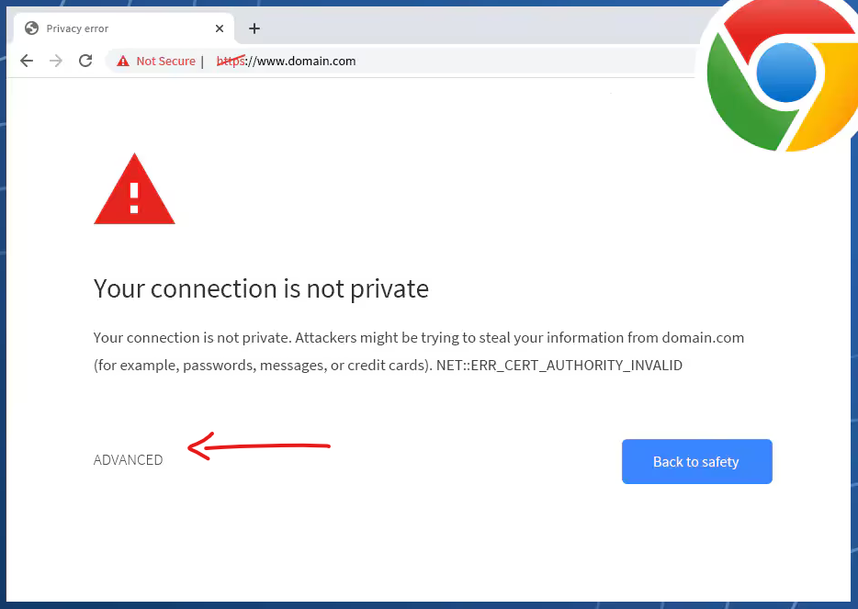
now you will have an app installed and should be running, to check the printer connection, open the zebra browser print app, should be visible on the bottom right of the screen (system app tray), right click and go to settings
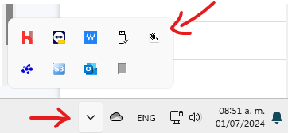
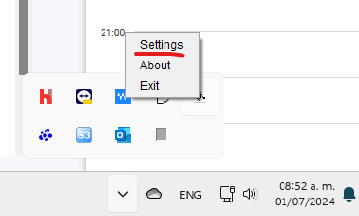
On the settings screen, click on "change" on the top section:
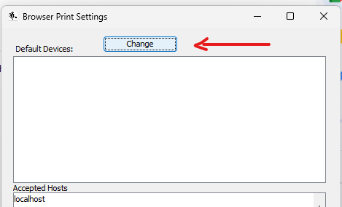
You should get a screen with a dropdown list with the serial number/ip address of your printers, then click on "set", you may now close the app, and go back to the Angelpaw portal, do a browser refresh, you will get a popup to allow the printer, once you allow just do one final refresh of the browser, then you should be able to scan a service (on the Angelpaw portal “Care center” screen from the left menu) and click on “print ss barcodes” or packaging barcodes and get the service barcodes.

